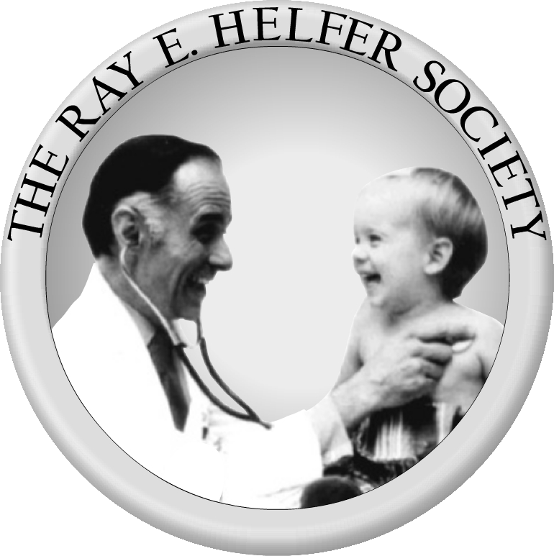
The Ray E. Helfer Society
218 Glorieta Drive
St. Augustine, FL 32095
Phone: 630.359.4273
Web: www.helfersociety.org
E-mail: info@helfersociety.org

Ray E. Helfer Society Annual Meeting Scholarship Application

The Ray E. Helfer Society Annual Meeting Scholarship was established by the Helfer Society to encourage trainees to consider a career dedicated to the care of maltreated children. The Annual Meeting of the Helfer Society is a mid-sized meeting that promotes exposure to cutting-edge research dedicated to Child Abuse Pediatrics, as well as the opportunity to network with early, mid-career, and senior mentors. The meeting will be held April 16-19, 2023, at the Loews Ventana Canyon Resort, in Tucson, Arizona. Helfer will be having a hybrid meeting with live presentations and virtual attendance option as well. This scholarship is intended to support travel costs and meeting fees for a trainee to attend the Annual Meeting with the goal of increasing commitment to a career in Child Abuse Pediatrics by talented physicians.
Scholarships are available to medical students and pediatrics residents eligible for a Child Abuse Pediatrics Fellowship.
Applicants should complete the application form below and attach their current CV. A letter of support from a current member of the Society must be included as well. A subcommittee of the Society will review applications based on the likelihood that the scholarship will improve the potential of the applicant to apply for a Child Abuse Pediatrics Fellowship and have a productive career dedicated to the care of abused children. Successful applicants are expected to attend the large majority of sessions at the conference in person and are welcome for all social and most business and committee meetings.
Please send completed applications to dbandy@helfersociety.org. Applications will be accepted until January 13, 2023 and results will be communicated around or before February 10, 2023. Scholarships are to be used to support travel, lodging, registration, and other reasonable expenses incurred in the course of travel to the meeting (also see details in the application form). Expected length of applications is 1-3 pages. Please submit application and attachments in a pdf format!!!

Ray E. Helfer Society Annual Meeting Scholarship Application

This is a Microsoft Word fillable form. Simply place your cursor in the appropriate area to type your response. You may also prepare your responses in another document or “scratch pad” and cut and paste them into the appropriate space on the form below. Once done, be sure to save this form as a pdf before returning it to the Society.

**************

Name:

Level of Training: Medical Student Resident

Institution:

Expected Date of Graduation:

E-mail Address: Phone Number:

Name of Helfer member sponsoring your application:

Please describe any exposure to the field of Child Abuse Pediatrics:

Please describe any ongoing mentorship related to Child Abuse Pediatrics:

Please describe any scholarly contributions (completed or in progress) related to Child Abuse Pediatrics. Scholarly contributions include, but are not limited to: original research; quality improvement; manuscripts; teaching; innovations in clinical care; administrative work; or service/advocacy:

The Helfer Society is committed to promoting an inclusive and diverse workforce. Please share how you would contribute to this vision:

What are your current near-term plans?

How will this scholarship improve your ability to ultimately contribute to the care of abused children?

Funds requestable in scholarship – the Scholarship will provide you with up to 4 nights at the meeting hotel, the meeting registration fee, ground transportation up to $150 (for parking receipts, transport, or mileage) and airfare up to $400. We do not cover rental cars or a per diem as many of your meals are provided at the meeting. Please provide an estimate of your travel expenses when submitting the application and itemize the amounts. Airfare will be reimbursed in person, at the Annual Meeting. (Please also list any additional funding sources that you have already identified to assist with the cost of attending the Annual Meeting):

**************

Please save the application form as a pdf and e-mail your completed application form along with your current C.V. and a letter of support from the Helfer member sponsoring your application to dbandy@helfersociety.org by January 13, 2023.

